Jan 19, 2016 at 1:22pm
Quote

Post by wetsand on Jan 19, 2016 at 1:22pm
Parable
Like the instar tunneling to the surface.
We must shed our own circumferences. Find the
divinity within and emerge.
- A clue that points toward 761.mp3 file
- A key that is used to decode the rest of the text taking the position of the runes to create numeric sequence
- A key that is used to decode the rest of the text taking the position the English letter position eg A = 0, to create a numeric sequence.
- A clue that points towards the number 1,595,277,641 notable as not being in the title this time.
- A clue that points to the key phrase 'the instar emergence'
- A clue that reminds us about Gematria totaling, as this poem has each line add to prime, that create the big number 1,595,277,641
- A method to select runes from the main text, in English if the key was 'Hello' you would search main text of random runes for the first H, take the next rune to the right, then search from their for the next E, take the rune to the right.

besharam  New Member    Posts: 1 | Jan 20, 2016 at 5:40am  Quote  Post by besharam on Jan 20, 2016 at 5:40am  There are two possible references to "Instar" within the liber primus:  First is an actual instar - a young cicada on page 2:  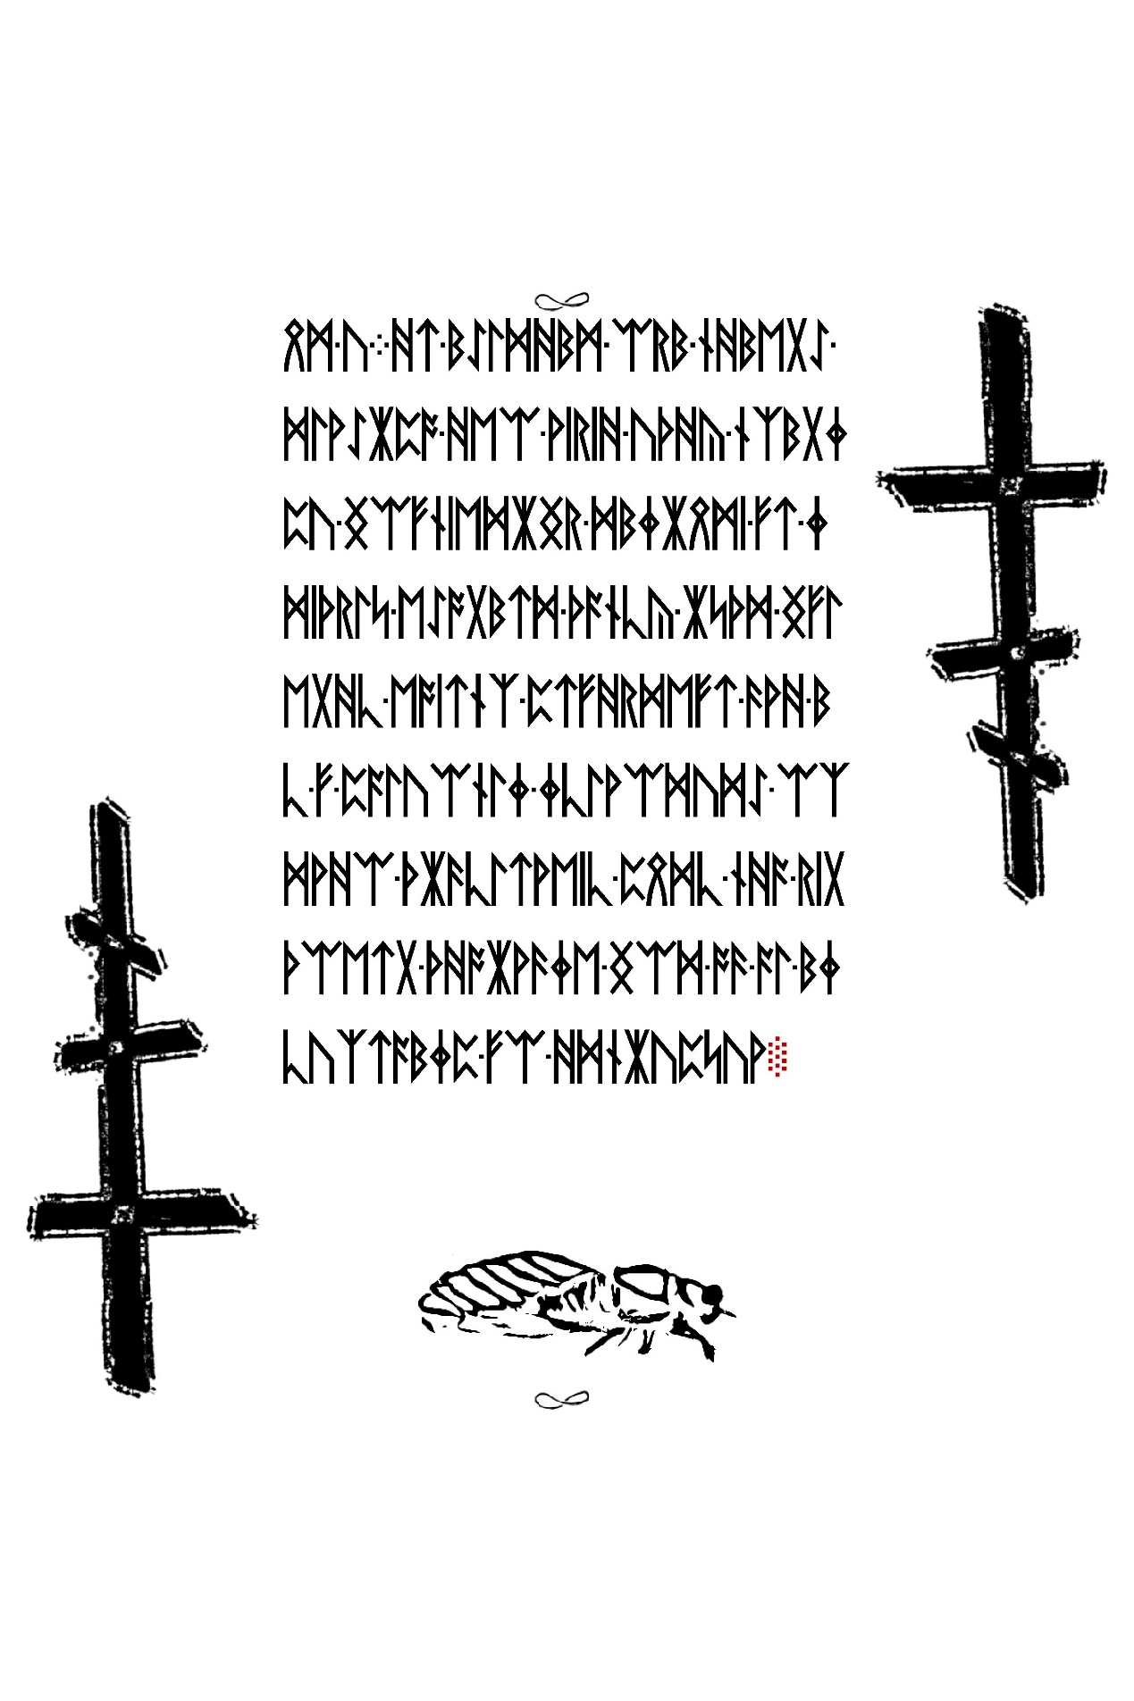  Second is the star indentations that show when you change the contrast on pages with mayflies:  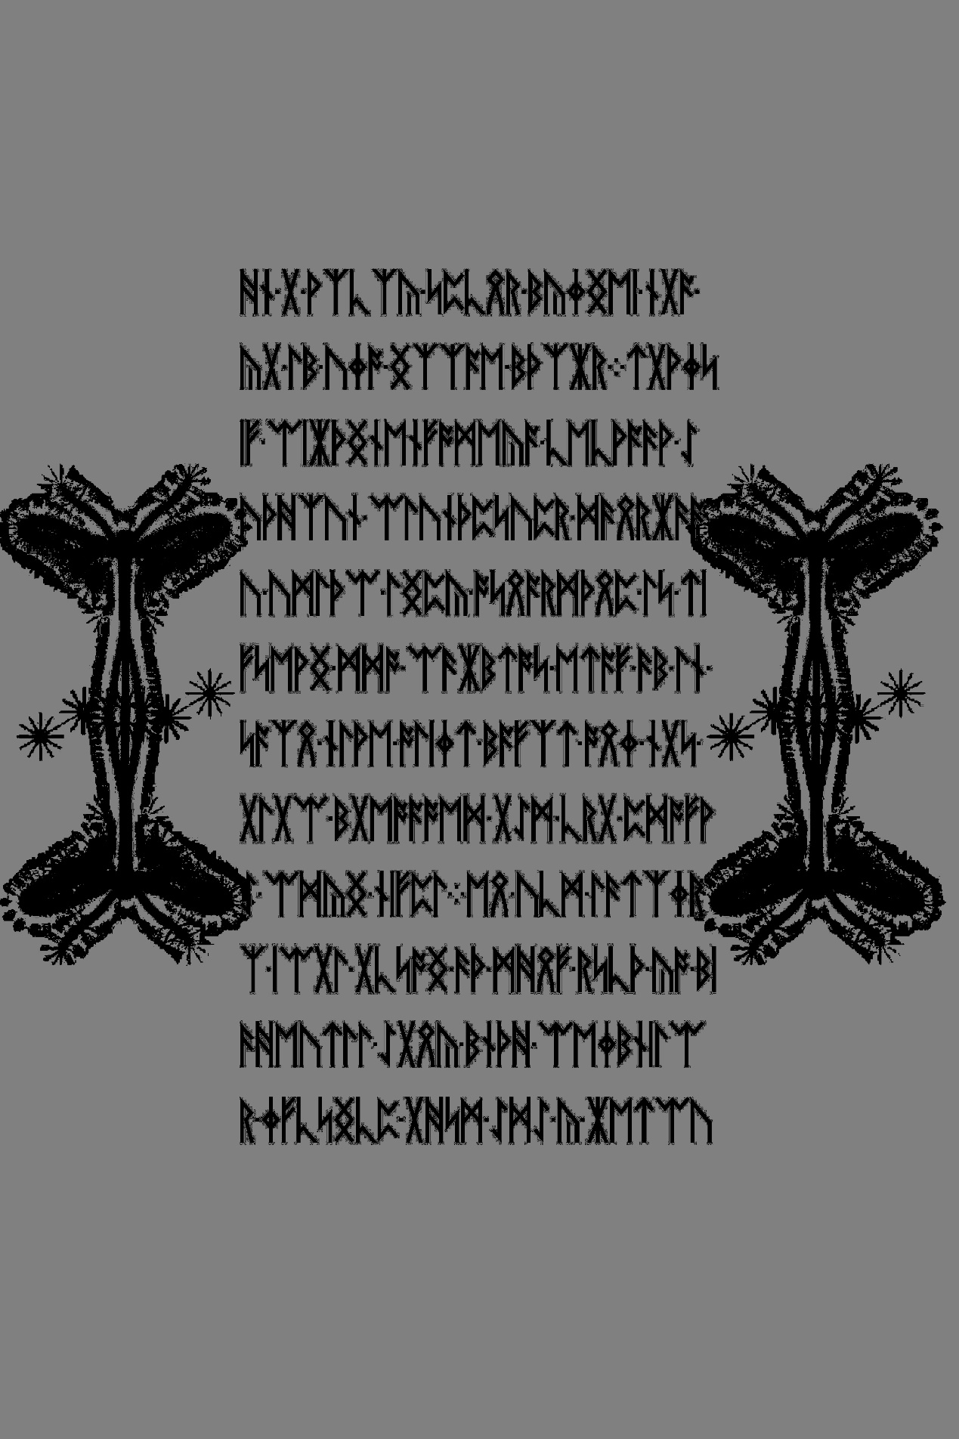
 | Last Edit: Jan 20, 2016 at 5:41am by besharam

genpop44  New Member    Posts: 5 | Jan 13, 2017 at 2:59pm  Quote  Post by genpop44 on Jan 13, 2017 at 2:59pm  In the original parable, there were “\n” at the end of the lines. These mean “new line”.

Oxymoran  Guest   | Apr 11, 2017 at 7:42pm via mobile  Quote  Post by Oxymoran on Apr 11, 2017 at 7:42pm  So one of the main points of Liber Al Legis is that "Every man and every woman is a star". From this Crowley derives the main law of Thelema, Do as thou wilt shall be the whole of the law. I think that the fact that this parable was brought up again, unencrypted no less, is pointing us back to Liber Al Legis. 3301's philosophies are very much Thelemic from what I have seen. Not to mention that this is called the Liber Primus. Unfortunately, I don't know shit about decryption. But the occult is my jam.  Was anything ever done with 1,595,277,641? 1, 277, 641 are all prime, but 595 is not. But if you combine 595, you get 19 which is prime. And then you have an ascending set 1,19,277,641. Or if you combine all 10 numbers you get 47, also prime. If you combine each set individually, you would come out with 1, 0 (or 1, I am not sure if 10 reduces to 0 or 1, I would appreciate guidance on this), 7, 2. If it is 1072 maybe that is the order to decode Liber Primus? There is a 0 page after all. Or possibly the verses 1,0,7,2 in Liber al legis hold clues to the decryption?

silentwater  New Member    Posts: 2 | Oct 6, 2019 at 11:57am  Quote  Post by silentwater on Oct 6, 2019 at 11:57am  As I first saw these pages, pattern recognition came to my mind. At page 57 there is a bitmap with the rough shape of a cicada, but at the end it isn't. It's just mirrored in

